Overview and Privacy Information
This handout is a “quick start” summary. It does not contain absolutely all the information needed to create a site or use VIUBlogs. If you have questions, please contact learnsupport@viu.ca

VIUBlogs are public by default but you can adjust your settings to make them more private. If you post something publically it is possible for Google to index that information. Even if you change your settings later the information could still be available through Google or other online searches.

You can create an ePortfolio, blog, or website in VIUBlogs. You can create up to 5 sites on your account.

Creating an ePortfolio, Blog, or Site in VIUBlogs (Wordpress)
There are videos and other supports available for all the following topics here: https://ciel.viu.ca/learning-technologies-innovation/technology-tools/viublogs/getting-started-viublogs

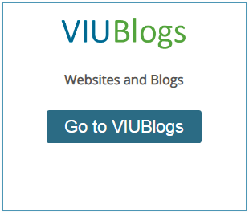
Logging in
- Go to https://learn.viu.ca/
- Under VIUBlogs click on Go to VIUBlogs
- On the right-hand side of the page click Login with your VIU account
- Log in with the same information you would use to log in to a computer on campus or VIULearn

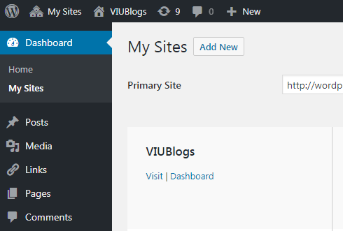
Creating a New Site
First – Decide on a title and URL (address) for your site. Your title can be changed later if needed, but the URL cannot be changed. Once you have decided:
- Click on Dashboard
- Select My Sites
- Click Add New
- Put in your Site Name (the URL)
- Put in your Site Title
- Select your Privacy level
  - We are suggesting Visible only to administrators of this site until you are comfortable with how the site is set up and what you are sharing.
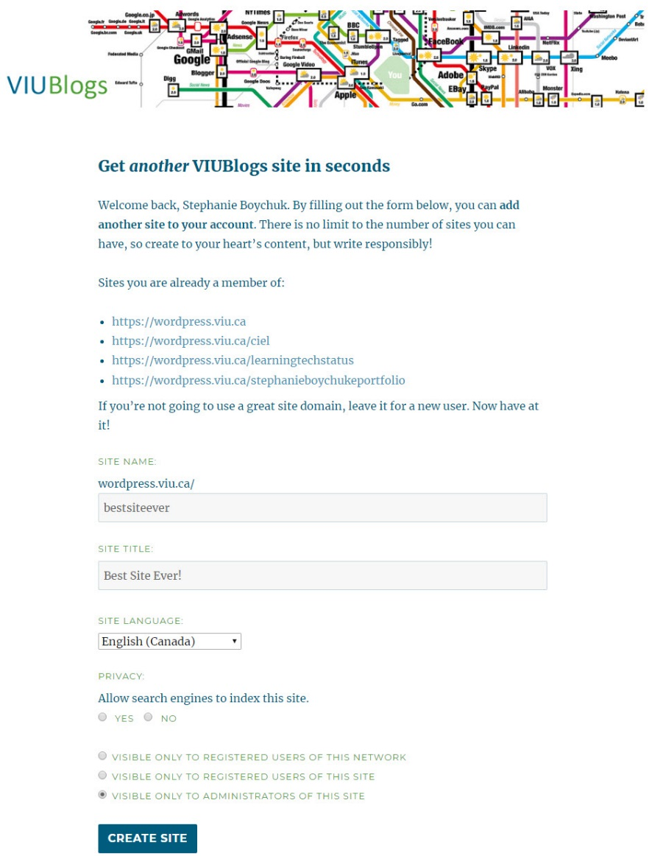
This will be your site Title which can be changed. Can be anything you like!
This will be your site URL and cannot be changed. Must be lowercase with no spaces.
You are the administrator of your site. If you select this option, only you can see your site right now.

Privacy Controls
Can be changed at any time from Settings and Reading.

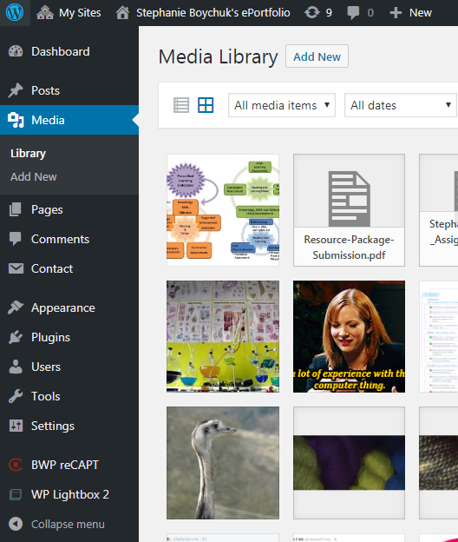
Adding Content to Your Site

Uploading Media
When you need to add a lot of media, it is easiest to do it from the Media Library.
- Click on Media
- Click on Add New
- Select Select Files or Drag and Drop your files
- Once a file is uploaded, you can click on it to:
  - Change the Title
  - Add a Caption or Alt Text
  - Add a Description
  - Delete the File
  - If the file is an image, limited editing of the image, including rotating and resizing, is possible

Creating Posts and Pages
Once you have uploaded all your media, you can create content on your site in one of two ways – as a Post or as a Page. Posts have the added advantage of being able to be tagged and put into categories. Pages can be “stacked” or nested together. There are more details on the differences between posts and pages here: https://en.support.wordpress.com/post-vs-page/

Posts | Page
Are entries listed in reverse chronological order on the blog home page by default | Are static and are not listed by date  Often listed at the top of the blog in a menu
Under “Posts” select “Add New” | Under “Pages” select “Add New”
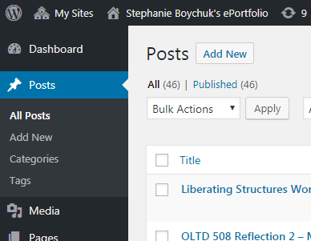 | 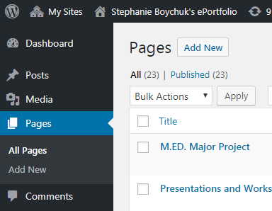

When you are adding content to either a post or a page, you have a new editor available to you – the Gutenberg editor. The Gutenberg editor is the more up to date and modern editor.

Adding Content with the Gutenberg Editor
The Gutenberg Editor allows you to create your content in blocks. Each block can have different kinds of content in it – like headings, text, images, media, and lists. Blocks can be edited independently from each other, and can be moved throughout the document.

On either a post or a page you can:
- Add a Title
- Add text by typing in a block
- Add images or media from your library by adding an image block
- Continue adding blocks to format your post or page, or edit your existing blocks
- Save your content as draft, preview your content, or publish your content
- Adjust document and block settings
  - You can also set the visibility of your post or page by selecting “Public”, “Password Protected” or “Private” in the document settings.

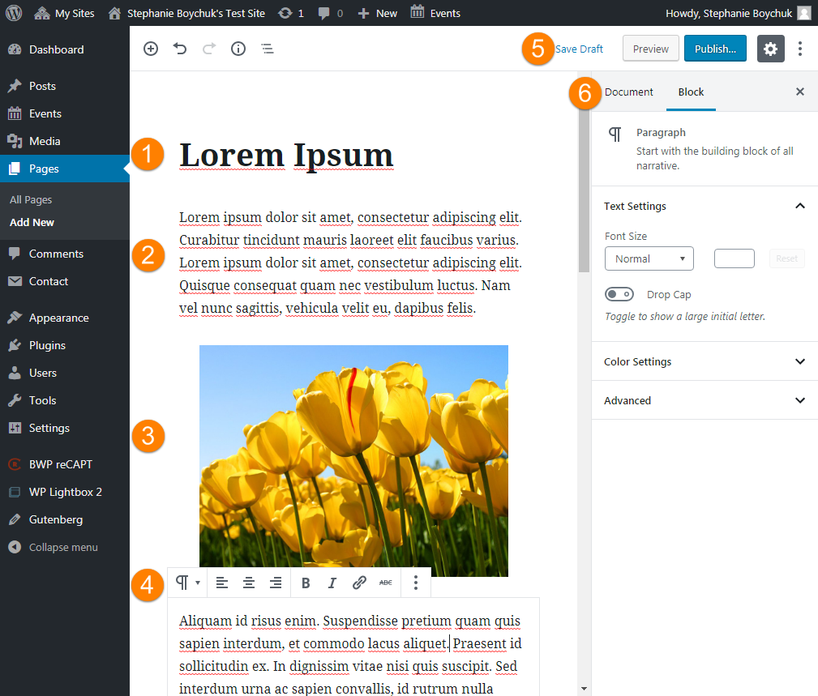

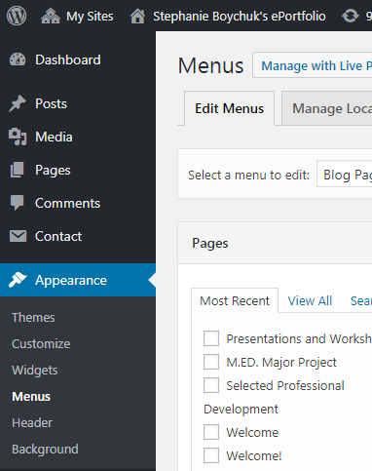
Menus
Menus are the way people will move around your site. Posts can appear as individual posts, or appear under the categories you have created for them. Pages will not appear on your site unless they are added to the menu or you have selected to automatically add them to the site.
- Click Appearance
- Click Menus
- Select the menu you want to edit or choose create a new menu
- Use the list of items on the left side of the page to click and drag pages, categories and posts into the menu order you want them to appear in
- Use the arrow to the right of the menu item to select options to move the item up, down or under on the list, or you can arrange them using drag and drop
- Make sure you save your menu!
- You can select here to automatically add pages to your menu
- You can also select whether or not the menu is the primary menu for your site
- Apply your menu from the Themes area

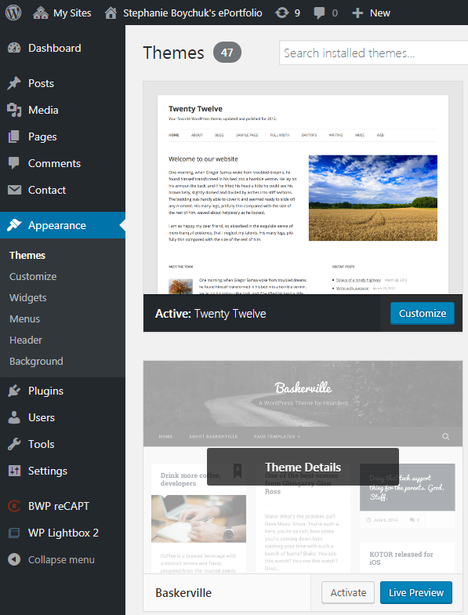
Themes and Customization
This is where you can change the colour scheme, background images, arrangement, structures and many other things about the look of your site. Note some features of menus and widgets do not work for some themes, so you may need to play around a little.
- Go to Appearance and Themes
- Select Live Preview to see your site on a different theme, and if you like it choose Activate
- Select Customize to edit your current theme
- From the Customize area you can:
  - Change your site title and tagline
  - Change the primary site colours
  - Add a header or background image
  - Change or apply your menu
  - Adjust your widgets
  - Change your front page

Widgets and Sidebars
You can customize the widgets and sidebars that appear beside your main site content. Each widget has a brief description below it to help you decide if you want it on your site.
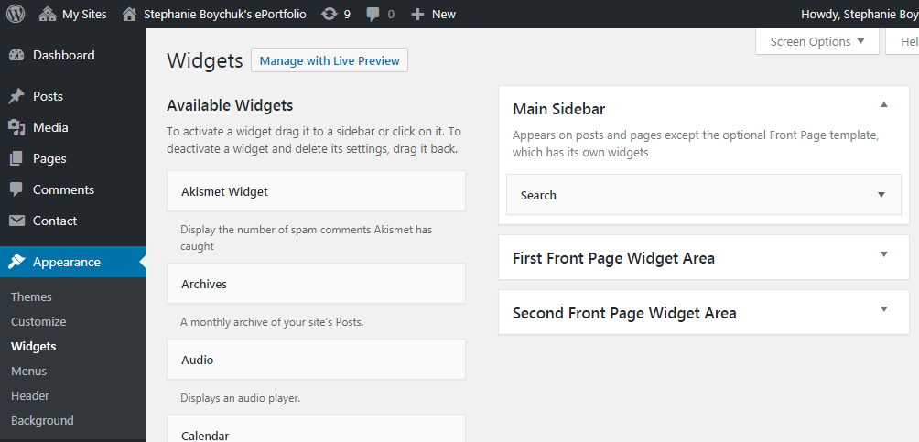
- Go to Appearance and Widgets
- You will see the available widgets on the left side of the page and the bars you can place them on the right side
- Use drag-and-drop to arrange what widgets (if any) you want on your sidebars

