Overview
One of the tools which we do not have available in the current version of VIULearn is a wiki or collaborative document editor. Collaborative documents allow multiple users, including both instructors and students, to edit a document. These can be used for brainstorming ideas, having students review and edit each other’s work, or for group projects.
One expert tip to start using collaborative documents with VIULearn is to integrate Google Docs into your VIULearn course site. Using Google Docs you can secure and protect the document within a password protected space but allow users within your course site to edit the document without logging in to Google. To do this you have to set up the Google Doc to be editable by anyone with the link, then embed the document in your course site.
It is important to note that because we are using Google Docs, which stores data on US servers, students and instructors refrain from entering personal or identifiable data into the Google Document. If such data is required in the collaborative document please refer to this page on Maintaining Privacy while Supporting Innovation.
To add a Google Docs collaborative document to your VIULearn course you will need a Google Account. Login to https://drive.google.com and create a new document.

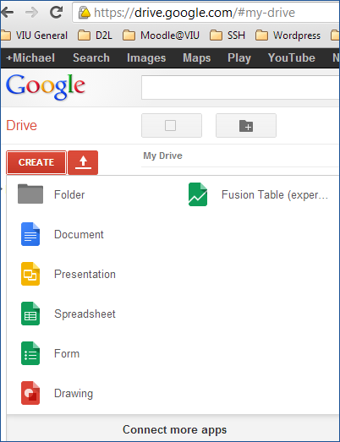
Give your document a name and then click the big blue ‘Share’ button in the top right corner. By default the sharing options for the document are restricted to private access. You will want to change this to allow collaborative editing. Click the change button next to the text “Private – Only the people listed below can access”.
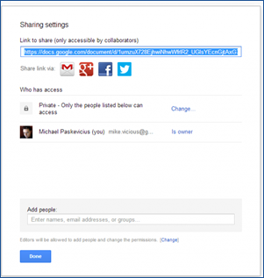

Now we are going to change the options for this document to allow “Anyone with the link” to edit. This will allow users who see this document in VIULearn to edit freely without a Google login. Change the visibility option to “Anyone with the link” then also change the access to “Can edit”.
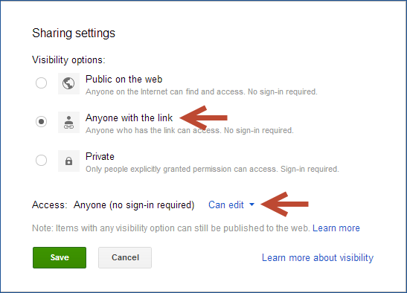
You will now be given a URL which you can use to share the document with collaborators.
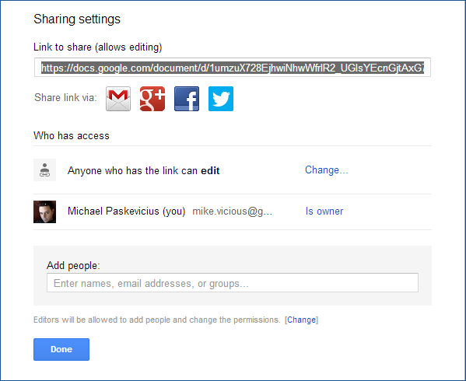

Navigating back to the VIULearn course site in which you want to add the collaborative document, go to your content tool and find the module in which you want to place the collaborative document. Click create a new link.
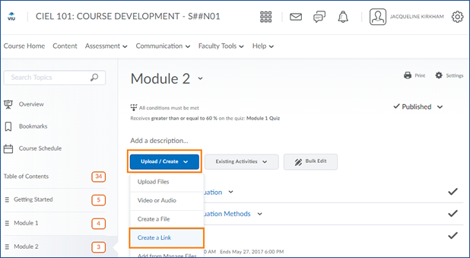

Here you can give your link a name and copy the URL that you obtained in Google Docs after creating the document. I recommend that you do not used the open document in new window option. Click create!
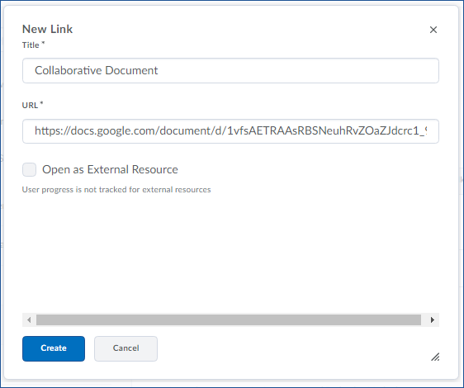

You now have a collaborative document embedded in your VIULearn course site! Your students will be able to collaboratively edit this document.
