This handout will review accessing the Quiz Tool and beginning the quiz creation process. This video will focus on the Properties Tab of the quiz editing screen, which allows you to name your quiz, add questions to it, and add text information to it. This video assumes that you have already created your questions in the Question Library. Please see our Question Library VIULearn Help Videos for more support on creating questions.

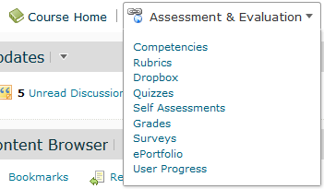1. From your Course Home page, choose Assessment and Evaluation and Quizzes.

2. You will be taken to the Quiz tool screen.

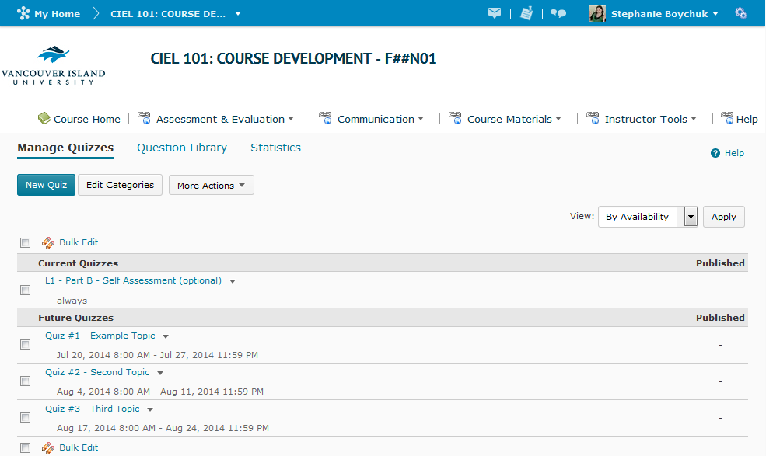

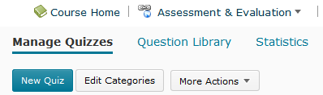3. From here, choose the blue New Quiz button.

4. The first screen you will see is the Quiz Properties tab. At the bottom of the page you will see a floating bar with a blue Save and Close button, as well a grey Save and Cancel
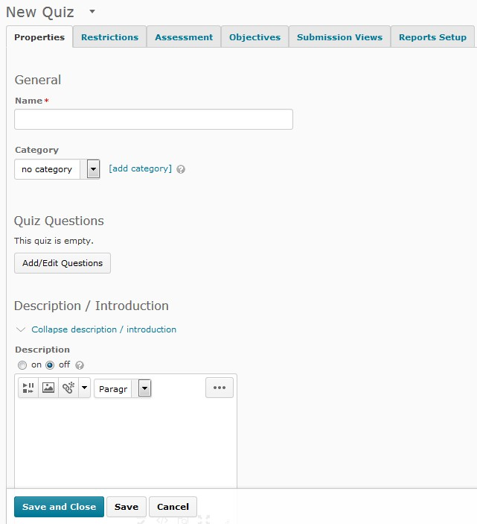buttons. This bar will stay at the bottom of the page not matter how you move on the page. You can also save and continue by moving between tabs in the quiz editing screen.

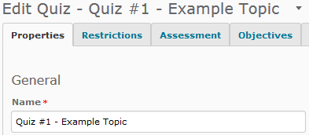5. On the Properties tab, the first thing you must do is name you Quiz.

a. It is suggested that you include the word “Quiz”, “Exam”, “Assessment” or other

triggering word so students understand what activity they are supposed to complete.

6. Once you quiz is named, you can add it to a category if you wish, but it is not required.

Categories are a way of organizing or labelling your quizzes on the Quiz tool screen.

7. To add questions to your quiz, choose the Add/Edit Questions button under the Quiz

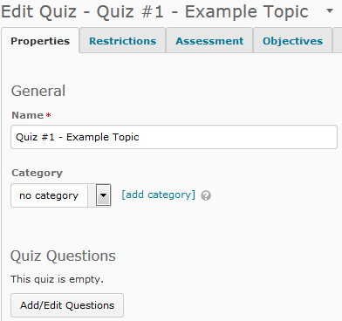Questions heading to import questions from the Question Library into your Quiz.

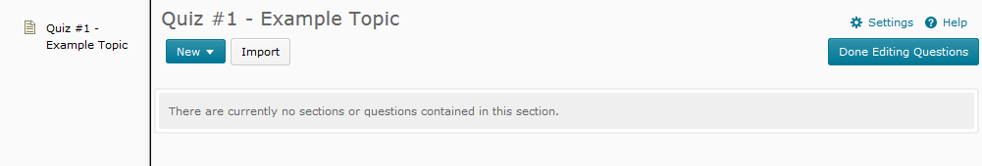8. The screen you see is very similar to the Question Library screen. You can tell you are in the Quiz Add/Edit questions screen because the name of the quiz will appear in the top left hand corner of the page.

9. In the Add / Edit screen, you can create new sections to organize your questions the same way you did in the Question Library. Additionally, you can create Random Sections, which will randomly shuffle the questions imported into them. If you would like to use this
feature, please contact learnsupport@viu.ca for support or see the searchable Desire2Learn

help for instructors available from your My Home page.

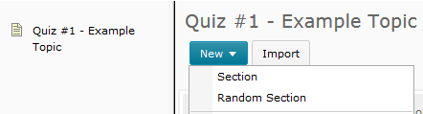

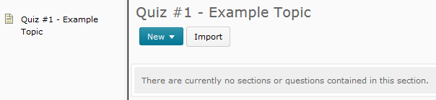10. To import you quiz question, choose the grey Import button.

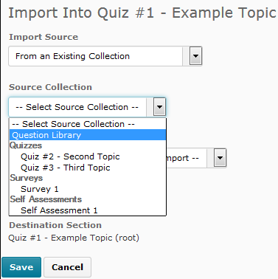11. Under Source Collection, choose either the Question Library, or another Quiz that contains the questions you want.

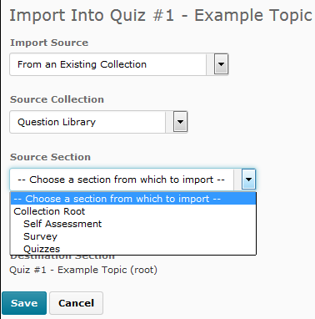12. Under Source Section choose the section, or folder, that contains your questions. If you have not organized your Question Library into sections, choose Collection Root.

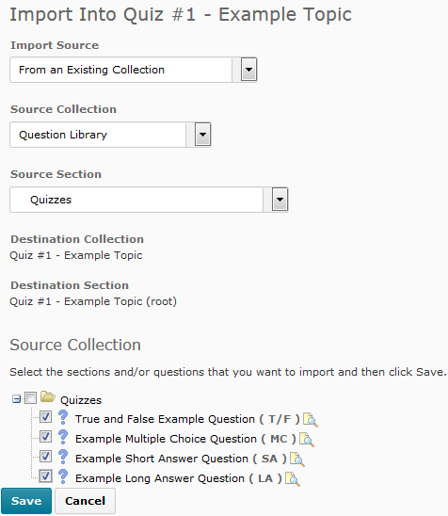13. Select the questions you want, and choose Save.

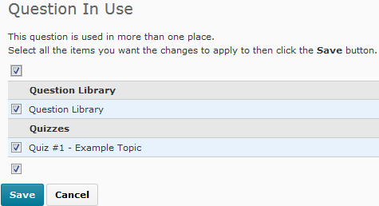14. If you need to edit your questions, you can click directly on them to open the question editing screen that you would have seen in the Question Library. If you make changes to a question, it is highly suggested that you save the changes in all the places that question appears so you do not have different copies off the same question in different places.

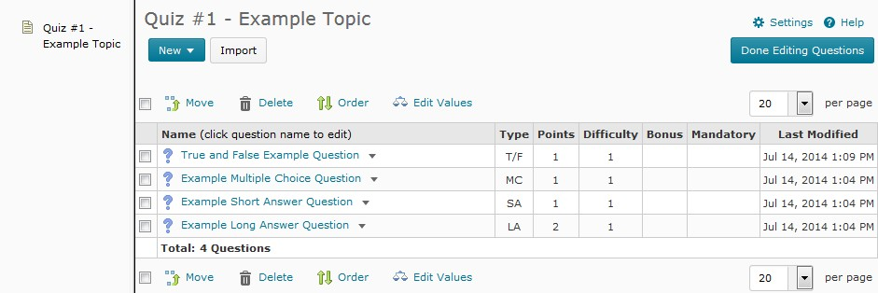15. When you are finished editing your questions, choose the blue Done Editing Questions button in the top right hand corner of the screen. You will be taken back to the Quiz Properties tab.

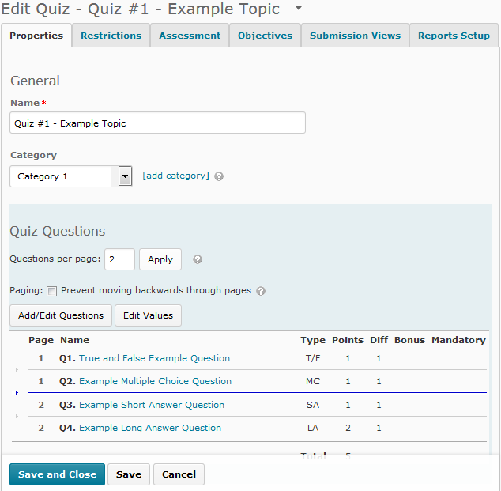16. It is strongly suggested that you use the Questions per page option to place no more than 5 questions per page of your quiz, as students’ attempts are automatically saved when they move between pages. If you wish to adjust the questions that appear on each page, click on the grey arrow to the left of the question list to insert a page break, or click on the blue arrow to remove a page break.

17. Under the Description / Introduction heading, you can click on Expand description / introduction to add information about the quiz. It is highly suggested that you add information such as the start and end dates, as well as the time limit of the quiz if there is one. This is an optional setting.
18. Under the Page Header / Footer heading, you can click on Expand page header / footer to

add information to either the top or bottom of every page of your quiz. This is an optional setting.
19. Under the Optional Advanced Properties heading, you can click on Expand optional advanced properties to allow hints, disable right or control click to stop users from printing the quiz questions, and disable alerts from within VIULearn. You can also choose to add your email address into the Notification Email area if you wish to get an email when a student submits a quiz. These are optional settings.

