This handout will continue the quiz creation process. The Assessment Tab of the quiz editing screen allows you to link your quiz to the VIULearn gradebook, set automatic grading, and set your attempts and grade calculation options. To review the Properties tab and the initial steps to creating a quiz, please see handout one in the Creating Quizzes 1 – The Properties Tab handout.

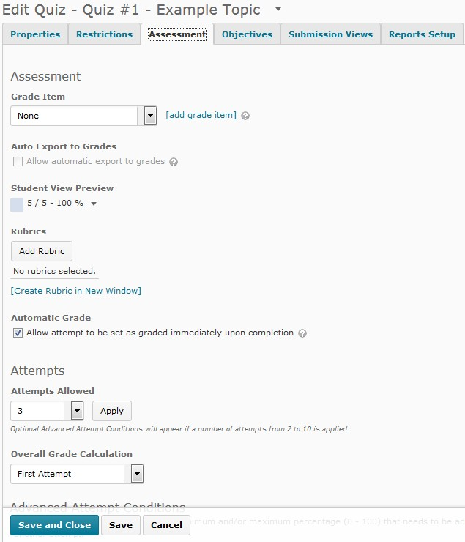1. At the bottom of the page you will see a floating bar with a blue Save and Close button, as well a grey Save and Cancel buttons. This bar will stay at the bottom of the page not matter how you move on the page. You can also save and continue by moving between tabs in the quiz editing screen.

2. Under the Assessment heading, you can choose a grade item to link to your quiz using the drop-down menu. Grade items will only appear on the list if they are not currently connected to another activity.
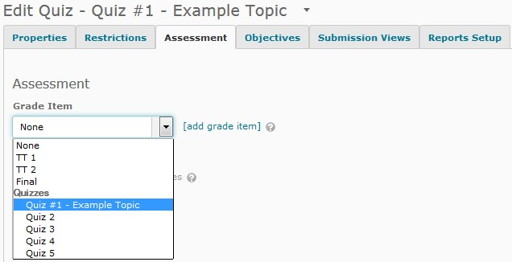

a. It is strongly suggested that you create your grade items in the Grades tool and not in the Quiz tool.

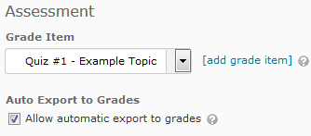3. If you connect your quiz to the VIULearn gradebook, you can choose whether or not to automatically export the quiz grades to the gradebook.

a. You can only check this option if you have linked your quiz to a grade item.

b. If you are using long answer questions or another question type you need to manually grade, it is suggested you leave this option unchecked.

4. You can attached a Rubric to the quiz if desired

a. This will not display the rubric beside all questions, so is not the most effective use of the rubric tool.

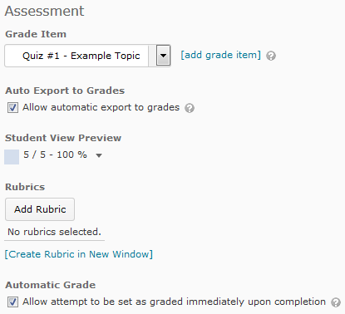5. The Automatic Grade option will mark a student’s attempt as graded immediately after it is completed. This setting can be used to save time if your quiz contains only question types that can be automatically graded.

6. Under the Attempts heading, you can set the number of attempts allowed on your quiz. If you set the attempt to a number between 2 and 10 and choose Apply, you will see Advanced Attempt Conditions appear.

Quizzes- Creating Quizzes 3- The Assessment Tab

7. Advanced Attempt Conditions allow you to set a minimum or maximum grade that must be achieved on the previous attempt to be granted another attempt. You can choose to either leave these options blank or fill them in. You can also choose how to calculate the overall grade for the quiz using the drop-down menu.
Attempts

Attempts Allowed
3 B Apply
Opoon•l Adv•rte«/ Atteompr eoncJ,aons will •ppur 1f • number of •rremprs from 2 ro 10 Js •pplied

OVerall Grade calculation

First Attempt

Advanced Attempt Conditions
To restrict access to a ttempts, enter a minimum and/or ma ximum peroenta9e (0 · 100) tha t needs to be achieved on the previous attempt to qualify for
another attempt.

If the minimum and/or maximum percentage is left blank,it will not apply.I f both are left blank,then there is no restriction.

Attempt 2 - Min: | 0/o Max: | 0/o on Attempt 1
Attempt 3 - Min: | 0/o Max: | % on Attempt 2

VANCOU V E R IS LAN D
vru­
UNIVERSI T Y

Centre for Innovation and Excellence in Learning viu.ca/ciel
learnsupport@viu.ca

Page4of4

