The Submission View Tab of the quiz editing screen allows you to control what students see immediately after a quiz is completed, as well as what students can see after a quiz is closed. To review the Properties tab and the initial steps to creating a quiz, please see handout one in the Creating Quizzes 1 – The Properties Tab handout.

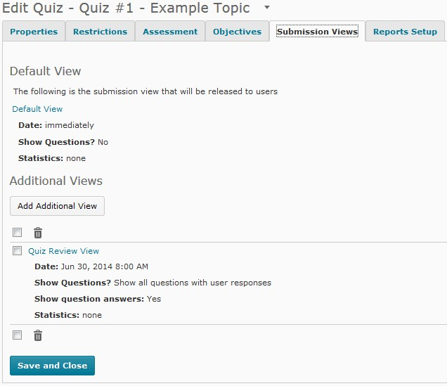1. At the bottom of the page you will see blue Save and Close button. You can save and continue by moving between tabs in the quiz editing screen.

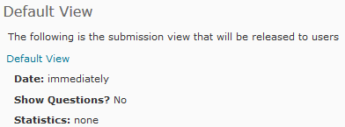2. To edit the information students will see when they complete a quiz, click directly on the blue Default View text.

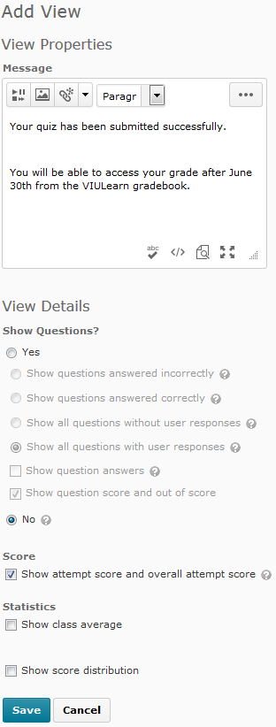3. You will be taken to the view editing screen.

4. From here, you can change the message students will see.

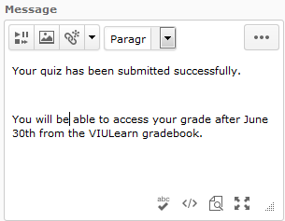

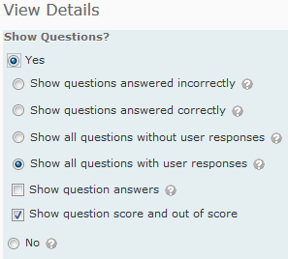5. You can also choose whether or not to show students the questions, their answers, and the correct answers.

6. There is also the option to show the students score, the class average and score distribution.
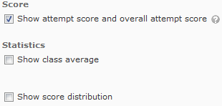

7. TIP: If you have to manually grade any questions, or if you have set your quiz to be open over multiple hours and/or days, you may not want to release the questions and score to students in the Default View area.

8. If you choose to make changes to the default view, choose the blue Save button at the bottom of the page to save your changes and return to the quiz editing view.

9. You can also add an Additional View to your quiz. Additional Views allow you to release the same information as the default view, but you have more control over when students see that information.

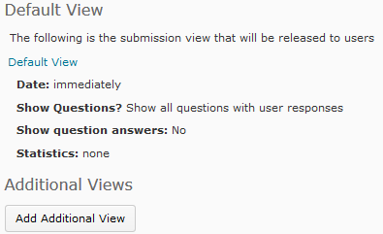10. To add an additional view, choose the grey Add Additional View button.

11. You will be taken to the view editing screen.

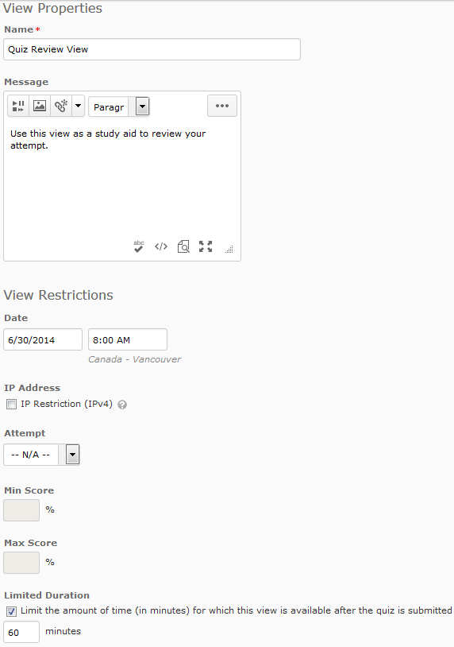

12. Give your view a name and add a message if you want.

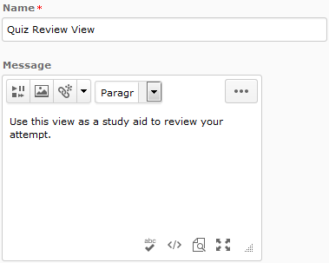

13. You can assign a specific date and time when the view will be available. You can choose to limit the amount of time a student has to access the view using the Limit Duration option.
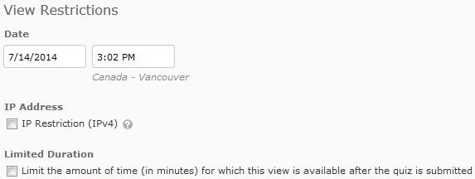

14. If you have allowed multiple attempts on your quiz you will also see the options to restrict the view until a student has completed a certain number of attempts or achieved a certain grade.

15. You can also choose whether or not to show students the questions, their answers, and the correct answers.

16. There is also the option to show the students score, the class average and score distribution.

17. If you choose to make changes to the additional view, choose the blue Save button to save your changes and return to the quiz editing view.

