The Reports Setup Tab of the quiz editing screen allows you to create reports on your questions, users and attempts. To review the Properties tab and the initial steps to creating a quiz, please see handout one in the Creating Quizzes 1 – The Properties Tab handout.

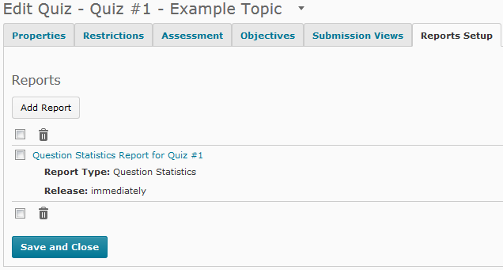1. At the bottom of the page you will see blue Save and Close button. You can save and continue by moving between tabs in the quiz editing screen.

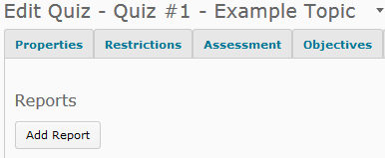2. To add a report, choose the grey Add Report button.

3. You will be taken to the New Report Screen.

4. Give your report a name. It is suggested that you name the report based on the information you want to get from it.
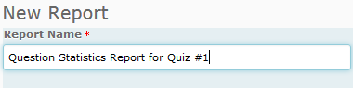

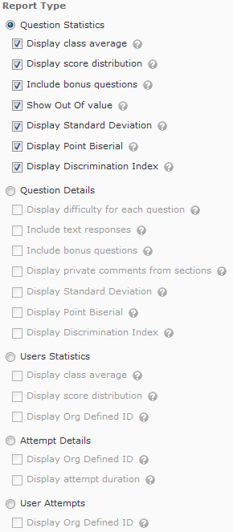5. Choose a report type. The report types are:

• Question Statistics

• Question Details

• User Statistics

• Attempt Details

• User Attempts

a. If you would like more information about each of the report types, please see the searchable Desire2Learn help for instructors available from your My Home page.

6. You can choose the date to release the report, or have the report release immediately.

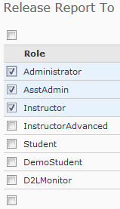7. Finally, you can choose who to release the report to. As student names and numbers will appear on all report types, do not release reports to students. Only release reports to people with instructor level privileges or higher.

8. If you choose to create a report, choose the blue Save button to save your changes and return to the quiz editing view.

