Embedding Video from YouTube and VIUTube

First, copy the embed code from either YouTube or VIUTube

YouTube Embed Code

1. Find the video you want to embed and open it

2. In the ribbon below the video choose “Share”
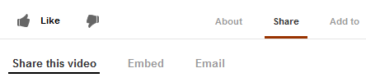and then click on “Embed”

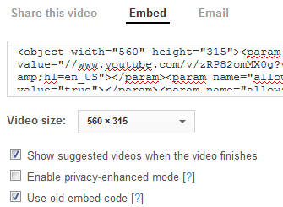3. Scroll down and make sure “Use old embed code” is checked

4. Click on the text box with the code in it. Hold down the Ctrl button and A button on your keyboard to select the entire code.

5. Hold down the Ctrl button and C button on your keyboard to copy the code.
VIUTube Embed Code

1. Navigate to https://viutube.viu.ca

2. In the top right of the screen, click on “login”
and login using your capitan credentials

3. Find the video you want to embed and open it

4. In the ribbon below the video choose “Get
Embed Code”

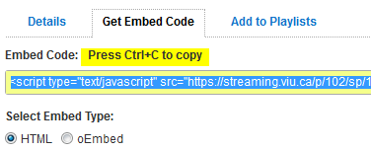5. You will be prompted to “Press Ctrl+C to copy”

Centre for Innovation and Excellence in Learning Page 1 of 3

Next, use the embed code to insert the video into your VIULearn (Desire2Learn) course

In VIULearn (Desire2Learn)

1. Create an HTML page or edit an existing HTML page
• For instructions on how to do this, please contact learnsupport@viu.ca

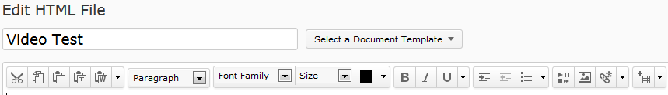2. From the HTML page, choose “Insert Stuff” from the editing bar

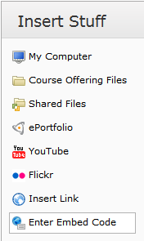3. Click on “Enter Embed Code”

6. Click inside the embed code box and then hold down the Ctrl button and V button on your keyboard to paste the code.

4. Choose the blue “Next” button at the bottom of the screen (you may have to scroll down to see it).

5. You will see a video preview. If the preview does not appear, click on “Refresh Preview”.

6. Choose the blue “Insert” button at the bottom of the screen (you may have to scroll down to see it).

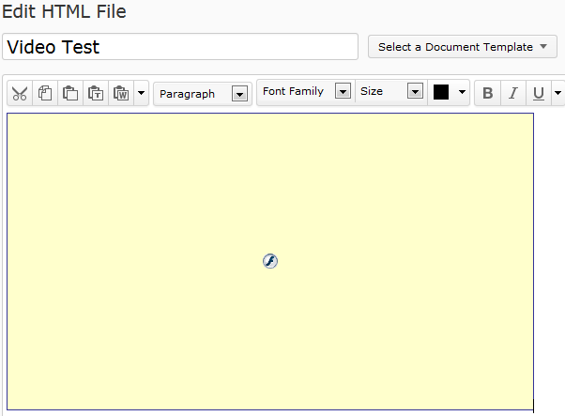7. Your video will appear as a yellow box in the HTML page

8. To view the video, scroll to the bottom of the HTML editing screen and choose the blue button
(either “Publish” or “Update”).

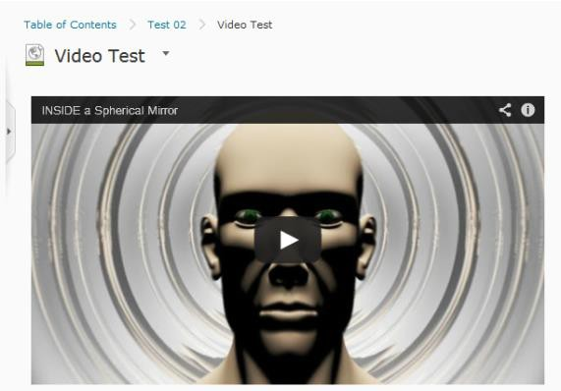9. In the content viewer, you can now watch the video

