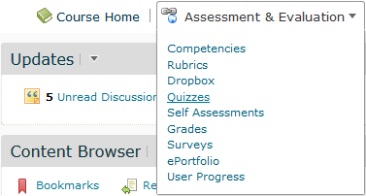The quiz tool in VIULearn allows you to create quizzes and exams in VIULearn.

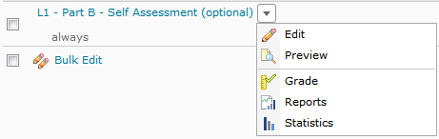Depending on the Question types you choose, your quizzes can be self-marking, or require you to go over student submissions and grade them.

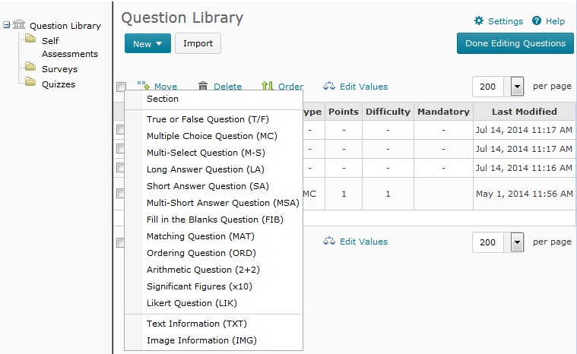The quiz tool works in combination with the Question library. You can build your questions in the question library, and import them into your quizzes.

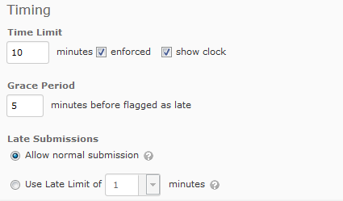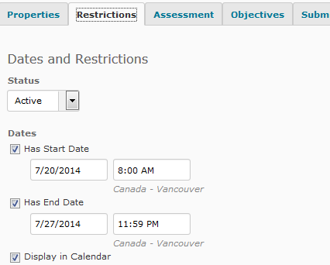You control the start and end dates of your quiz, as well as the time limit. For example, students could have access to a quiz for one week, but only have 10 minutes to complete it once they open it. You can also choose how strictly your time limit is enforced.

The VIULearn quiz tool also allows you to add special access for some users – such as students with disabilities who require additional time or a student who needs to write the quiz outside of the normal start and end dates.
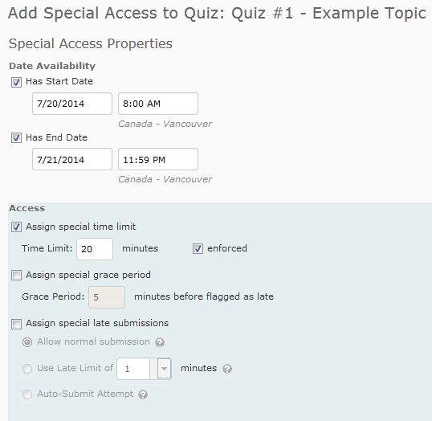

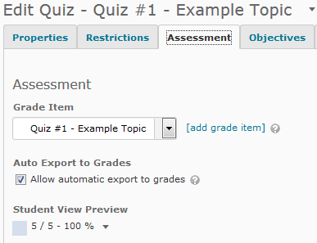You can connect the quiz tool to your gradebook in VIULearn so you do not have to manually move grades between the tools.

You can also generate statistics and reports on class or individual student achievement, as well as detailed statistics on individual questions.
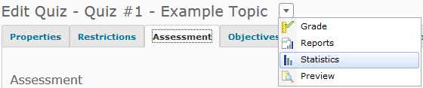

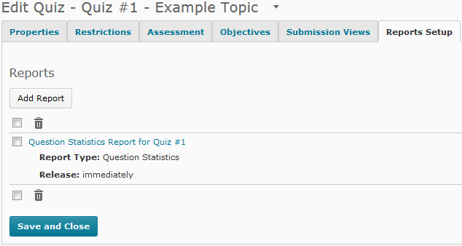

For more detail on using the Question Library please see our videos on creating questions and managing the Question Library.

For more detail on creating a Quiz, please see our Quizzes video series.

