Overview
Release conditions allow you to create a custom learning path through the materials in your course. When you attach a release condition to an item, users cannot see that item until they meet the associated condition.
Note: Once a user meets a release condition, the condition is cleared for that user and cannot be reset.
For example: If I set a condition on Module 2 that users must score 60% minimum on Quiz 1 to see the module and a learner scores 65%, Module 2 is unlocked. If there was a mistake in grading the quiz, and the actual score for the student should have been 55%, access to Module 2 is not revoked when I correct the grade on the quiz, even though the new grade would not meet the release condition.

Best Practices
Set up conditions before users access the course
Create all of your course materials and set up your release conditions before the course opens to users. This gives you a chance to check for mistakes in the conditions or for circular, contradictory, or unnecessary conditions. If you add new release conditions after users have accessed the course, users might be confused by resources disappearing. Since conditions cannot be reset, you also risk having users meet conditions before your resources are ready (e.g., accessing a content topic before it is finished).
Avoid unnecessary conditions
Each condition you associate with a tool takes additional time for VIULearn to process. Using as few conditions as possible to set up a learning path minimizes the amount of time that users spend waiting for pages to load.
Avoid circular references
A circular reference makes it impossible for users to satisfy a set of conditions. For example, if you set the condition that users must view a content topic before they can access an Assignment folder, and then set a condition that they must submit a file to the Assignment folder before they can access the content topic, you have a circular reference. Users can’t satisfy either condition without satisfying the other one first.
Circular references are more likely to occur with long chains of conditions. For example, a content topic that depends on a quiz that depends on an Assignment folder that depends on a checklist that depends on the content topic.
Avoid impossible conditions
Ensure that your conditions are not impossible for users to satisfy. If users are unable to satisfy a condition, they are unable to access the content or tools to which the condition is attached.
Avoid contradictory conditions
Contradictory conditions occur when two or more conditions that cancel each other out are associated with an item. For example, the conditions “User must achieve greater than 49.9% on Grade Item 1” and “User must achieve less than 50% on Grade Item 1” are contradictory. Users could not satisfy both conditions at the same time; they would not be able to see the item associated with these conditions.

Setting Up a Release Condition
To create a Release Condition you need to attach it to the item you want to restrict. To create a new Release Condition:
- Choose a Condition Type
  - This list is sorted into categories based on tools in VIULearn.
  - Some examples of categories are: Group Membership and Score on a Quiz.
  - Conditions can be based on users completing or not completing an activity
    - For example: Under the Content category you can set a Release Condition for users who “Visited Content Topic” or for users who have “Not Visited Content Topic.”

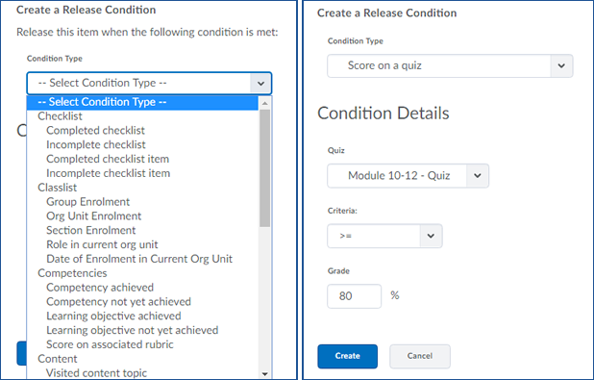

- Set the Condition Details
- Click Create
  - Once you have created a Release Condition, you can attach it to any item or activity in the course that allows Release Conditions.

Add a Release Condition to a Content Module or Sub-Module
Note: that you must set release conditions on Quizzes, Assignments, and Discussions from those tools in order to restrict access. A release condition locking a module or submodule will not prevent users from accessing those activities from the Course Navigation bar.
- In the Content tool, click on the Module or Submodule you want to edit.
- Click on the “Add dates and restrictions…” text beneath the topic you want to restrict.

- Under Release Conditions click Create to create a new Release Condition or Browse to choose from Release Conditions you have already created.

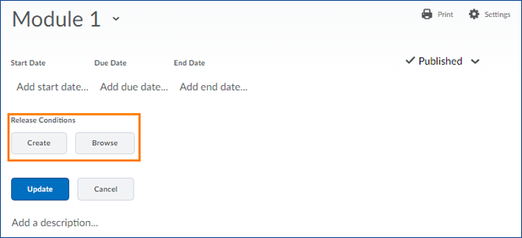

- Once you have attached at least one Release Condition, you will see a new drop-down box appear. Use this menu to choose whether users must satisfy all of the conditions (“All conditions must be met”) or only one (“Any condition must be met”).

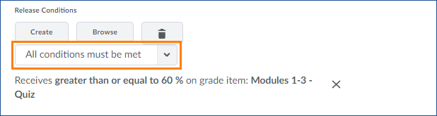

- When you are finished making changes to the topic, click the blue Update button to save your changes.

Add a Release Condition to a Content Topic
Note: If you have set a restriction on the module or sub-module a topic is in, you do not need to also set the same restriction on individual topics.
- In the Content tool, click on the Module or Submodule that contains the topic(s) you want to edit.
- Click the Bulk Edit button to access the dates and restrictions options for all of the topics in the (sub)module.

- Click on the “Add dates and restrictions…” text beneath the topic you want to restrict.
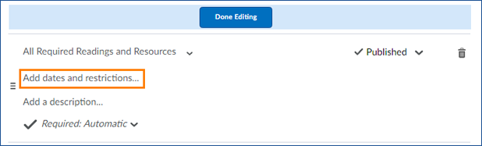
- Under Release Conditions click Create to create a new Release Condition or Browse to choose from Release Conditions you have already created.

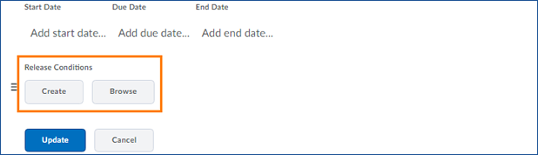

- Once you have attached at least one Release Condition, you will see a drop-down box appear. Use this menu to choose whether users must satisfy all of the conditions (“All conditions must be met”) or only one (“Any condition must be met”).
- When you are finished making changes to the topic, click the blue Update button to save your changes.
- When you are finished editing the topics in the (sub)module, click the blue Done Editing button.

Add a Release Condition to an Assignment Submission Folder, Discussion, or Quiz
- To attach a Release Condition to an Assignment Submission Folder, a Discussion Topic or Forum, or a Quiz, navigate to the Restrictions tab in that tool. (The image below is from the Quiz tool, you will see slightly different tabs in the other tools)

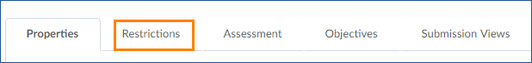

- Click on the grey Create and Attach button to create a new Release Condition or on the Attach Existing button if you want to add a condition you had previously created.

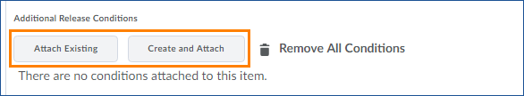

- Once you have attached at least one Release Condition, you will see a drop-down box appear. Use this menu to choose whether users must satisfy all of the conditions (“All conditions must be met”) or only one (“Any condition must be met”).

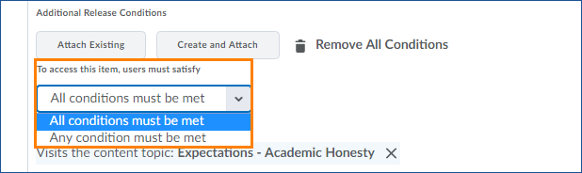

- When you are done attaching Release Conditions to your activity, click the blue Save and Close button.

