Overview
Before starting to work with the Discussion tool it is important to understand the language used in VIULearn.
Forums - are categories you use to organize your discussions, or the "house" that contains all your "rooms"
Topics - are where students can create threads, or the "rooms" where students can have discussions. There are two types of discussion Topics which can be created in VIULearn: Open Topics and Group or Section Topics. Choose Open Topic when you want to create a single discussion topic for all learners in your course.
Threads - are where students discuss the topic, or the conversations that happen inside the "rooms"

To Create a Forum
- Navigate to the Discussion tool by selecting Communication and Discussions from the Course Navigation Bar.
- Click the blue New button and choose New Forum.
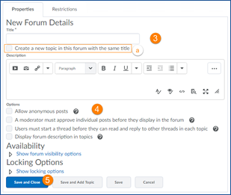
- Give your Forum a title and add a description if you wish.
  - You can choose to check the box for Create a new topic in this forum with the same title if you would like the system to automatically create a topic for you.

- Set any additional options

- Click the blue Save and Close button

To Create an Open Discussion Topic
- From the Discussion tool, click the blue New button and choose New Topic.
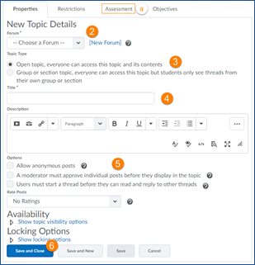
- Choose which Forum to place your Topic in.

- Choose Open topic, everyone can access this topic and its contents.

- Give your topic a name and add a description if you wish.

- Set any additional options.
  - If you wish to attach a grade item, click on the Assessment tab at the top of the page.

- When you are finished setting your options, click the blue Save and Close button.

