Overview
You can use the Groups Tool and Discussions Tool in VIULearn to create Group-restricted discussion topics and Group Assignment Submission Folders. This handout assumes you have already created your groups.

Create a Group Restricted Discussion and Group Assignment Submission Folder
- Go to the Groups tool by clicking Communication and Groups.

- Click on the Groups Category you want to create the group work areas for.
- At the bottom of the Edit Category page check the boxes for Set up discussion areas and Set up assignment submission folders
- Click the blue Save button
- First, you will set up the discussion area:
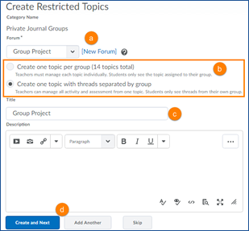

  - Choose the Forum for your discussion topic
  - Choose whether you want to create a separate topic for each group (this option may be best if you plan to assign each group different work) or whether you want to put all groups in a single topic where individual discussion threads will be group restricted (this is ideal if you want to grade the group discussion, or if you want to be able to post information relevant to all groups)
  - Enter a title and description for your discussion topic if available
  - Click Create and Next to move on or Add Another to create another discussion topic.
- Now we will set up the Assignment Submission Folders:
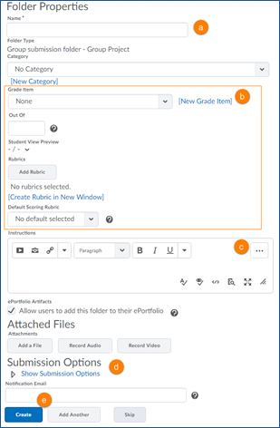
- Give the Assignment Submission Folder a name

- You can choose whether or not to associated this Assignment Submission Folder with a category or attach it to a grade item.

- Include any instructions or attachments

- Set your submission options
  - Click the blue Create button to create this Assignment Submission Folder and return to the Group Category editing screen, or click Add Another to set up additional Assignment Submission Folder

- You will see a confirmation screen summarizing what has been created. Click Done.
- Make any changes to your Group Category and then click the blue Save button.

