Overview

The groups tool provides you with the opportunity to put your students into groups. You can create group work areas for users with the Groups tool. You can use groups to organize users’ work on projects and assignments, or you can create special work areas for users with different learning needs

Best Practices
Before setting up groups you should know how you want to organize them. A number of things can affect how users enrol in groups, including:
- Setting groups up before or after you enrolled users.
- Enabling auto-enrolment in groups.
- Enabling randomization of users in groups.
- Enabling self-enrolment in groups.
- The enrolment Type you choose.
In order for users to enrol in groups automatically, Can be auto enrolled into groups must be enabled.
In most cases it is better to set up groups after the majority of users enrol in your course. This gives you a better idea of how many users you are organizing and how many groups you need. Setting up groups after enrolment can also ensure better distribution of users between groups.
While you can move learners from one group into another, this will cause them to lose access to any material they submitted to a discussion or assignment submission folder associated with their original group.

Understanding Enrolment Types
There are six different enrolment types available in the groups tool:
- # of Groups No Auto Enrolments – Specify a number of groups and manually enroll any number of learners into these groups.
- Groups of # - Each group is filled with the specified number of learners. When one group is full, the system automatically creates another. Depending on class enrolment and group size, this can result in one group with significantly fewer users than other groups.
- # of Groups – Learners are automatically enrolled as evenly as possible across a specified number of groups.
- Groups of # - Self Enrolment – Learners manually enroll themselves in a group. Group membership is capped at a number set by the Instructor. A new group is not created until the current groups are full.
- # of Groups – Self Enrolment – Learners manually enroll themselves in one of a specified number of groups
- Single user, member-specific groups – This will create one group for each user in your course and automatically name the group with the first and last name of the student.

Create a Group in VIULearn
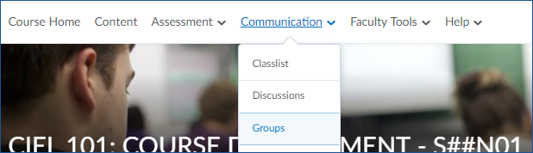
- Choose Communication and then Groups.

- Click the blue New Category button.

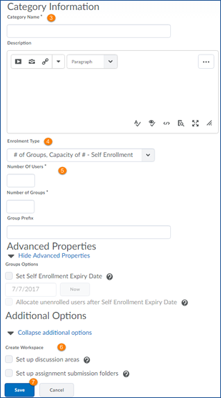
- Give your category a name and, if you wish
to, a description. These will be visible to
learners from the Groups tool.
- Choose your Enrolment Type.
- Enter any additional specifics for the
Enrolment Type you chose
  - Depending on the Enrolment type you may
be asked to specify the maximum number of
users for each group, the number of groups
you want created, or to set a date and time
after which users can no longer self-enrol in
groups.
  - You can also add a group prefix which will be
added to the name of any discussion topics
or assignment submission folders which you
create for the group.
- To create a discussion area or an assignment
submission folder for the group right away,
check the relevant box before proceeding to
step 7. You can always come back and set
these up at a later time.
- Click the blue Save button.

