Overview
You can use the Groups Tool and Discussions Tool in VIULearn to create private spaces where learners can share their learning with you. This handout will show you how to set up a single discussion topic in which each learner has a private thread which is named with their first and last name.

Create Single User Groups
- Go to the Groups tool by clicking Communication and Groups.

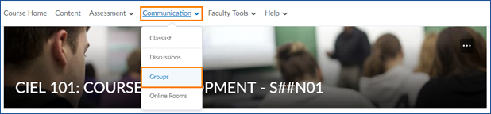

- Click the blue New Category button.
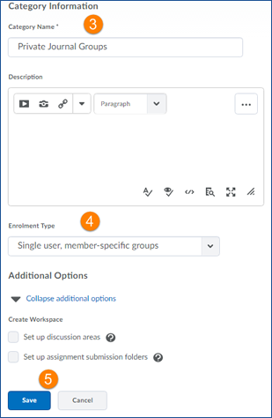
- Give your Category a name. You can also add a description if you wish.

- Set the Enrolment Type to Single User, member-specific groups.

- You can choose the click the blue Save button to create your groups without creating discussion or assignment areas, or continue on to the next steps.

Create a Private Discussion Area
- If you previously created groups, click on the groups’ category name to open the editing screen.
- At the bottom of the page check the box for Set up discussion areas.
- Click the blue Save button.
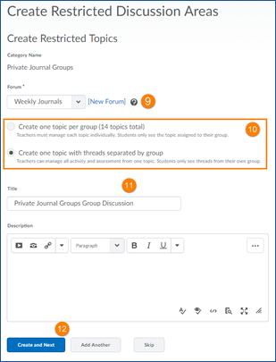
- On the Create Restricted Topics page, choose which Forum you want your discussions to appear or click New Forum
- Choose what type of topic you want to create:

  - Create one topic per group will create separate discussion topics for each learner

  - Create one topic with threads separated by group will create a single topic, but the threads each user creates within that topic will be private. This option may be best for you if you anticipate wanting to post to all groups at once, or if you will have several group discussions and want to minimize clutter on your discussion page.
For this example, we will choose Create one topic with threads separated by group.
- Give your Topic a name and enter a description or instructions in the Descriptions box
- Click the blue Create and Next button to create the discussion and return to the groups’ editing screen, or click the grey Add Another button to create another group restricted topic.

- When you are finished creating discussions, you will be taken to a confirmation page. Click Done.
- Click the blue Save button to be returned to the Groups page.
If you go to the Discussions tool, by Clicking Communication and Discussions, you will see your topic(s) have been created and show “Group/section restrictions” below the topic title.
