Best Practices
Do not make changes to group enrolment once students have begun submitting work or participating in a group discussion. When a user is moved from one group to a new group, they lose access to any submissions made under the old group.
If you need to reorganize your groups partway through a term, consider creating a new Group Category rather than altering the enrolment of your groups. This will allow all users to maintain access to their past work while allowing you to reorganize group members going forward.

View and Edit Group Enrolment
- Access the Groups tool by clicking Communication and Groups
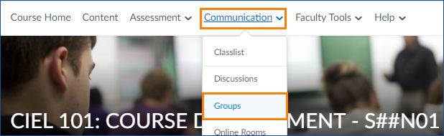
- If you have more than one set of groups, choose the group category you want to edit from the drop down menu
- Click the arrow to the right of the Group Category name in the table below and choose Enrol Users
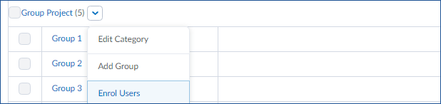
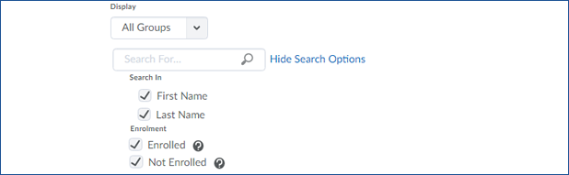
- You can use the search and filter options at the top to limit which learners display or scroll down to view the enrolment for all users

- You will see this small icon next to each user who is enrolled in at least one group. You will also see check marks in the group columns showing which users are in which group
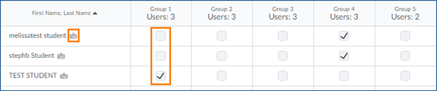
- To change a user’s enrolment, uncheck one box and check another.
- Click Save to save your changes or Cancel to return to the previous page without making a change.

Edit Group Settings
- Click the arrow to the right of the Group Category and choose “Edit Category”
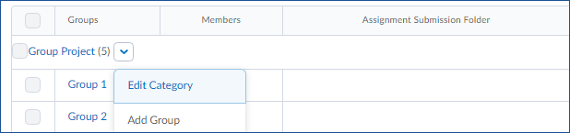
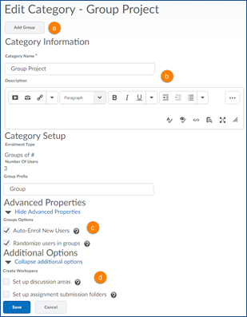
- From this screen you can:
  - Add a Group
  - Edit the category name or description
  - Change how new users are enrolled
  - Set up group discussion forums or
assignment folders
- Once you have made any necessary
changes, click Save.

